

Gulf Coast Area:
Industry Projections 2008 - 2018
North American Industry Classification System (NAICS)

Prepared by:
Workforce Solutions
November 2010

Next update Autumn 2012

GULF COAST AREA: Industry Projections 2008-2018

The Gulf Coast Area’s employment is projected to grow from 2,910,920 to 3,475,140 jobs by 2018, adding 564,220 jobs over the ten year period. The 19.4% growth rate is lower than the previously projected 24.1% for the 2006-2016 period. The Gulf Coast Area is expected to outpace the national annual average growth rate of 1.0 percent, and the state rate of 1.7%, increasing by an average of 66,295 jobs per year.
The Goods Producing Sector will generate over thirteen percent of the new jobs during the 2008-2018 period, adding 72,420 jobs. This is less than the last period, when 89,750 jobs were projected in this sector.

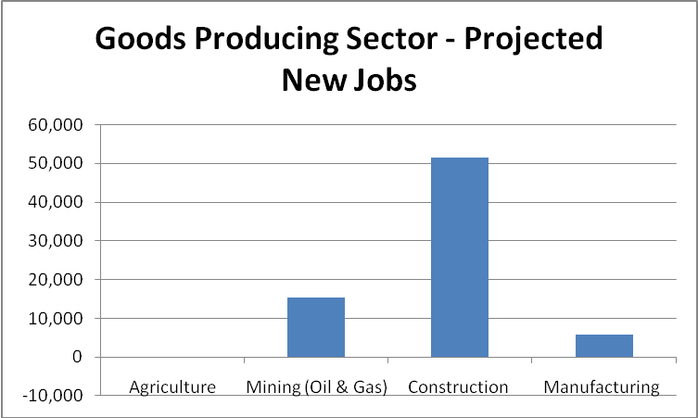

Construction will be adding the most jobs in the Goods Producing Sector, expanding by 51,460 jobs by 2018. A large amount of the increase in Construction employment is expected to be in Special Trade Contractors (NAICS 238), up 27,550 jobs, or 25.9% over the ten year period. Most of the projected job growth in manufacturing will be in Machinery Manufacturing (NAICS 332), up 3,190 jobs, and Fabricated Metal product (NAICS 333), up 2,440 jobs. These two industries are closely related to the oil and gas industry.
The Services Producing Sector will not only add the most jobs, but will also grow faster than the average for all jobs. The sector adding the most jobs, over the ten year period, will be Educational Services, public and private (NAICS 61) projected to add 98,080 jobs by 2018, a growth rate of 36.4%. Included in this sector is Elementary & Secondary Schools (NAICS 6111), projected to add 77,560 jobs by 2018. Health Care and Social Assistance (NAICS 62)
is projected to add 91,200 jobs by 2018. Ambulatory Health Care Services (NAICS 621) will account for forty-nine percent of the new jobs in Health Care, adding 45,090 jobs by 2018. A higher portion of the new jobs will be in doctor’s offices (Offices of Physicians NAICS 6211) and Home Health Care Services (NAICS 6216). Hospitals, public and private, (NAICS 622) are projected to add 27,210 jobs over the ten year period.
.

Social Assistance (NAICS 624) will have above average growth, 24.9 percent, adding 10,000 jobs by 2018. Child Day Care Services (NAICS 6244) accounts for fifty-four percent of the jobs, adding 5,430 new jobs.

TOP FIVE GROWTH INDUSTRIES WITH OVER 10,000 PROJECTED NEW JOBS
NAICS | INDUSTRY | NEW JOBS | % CHANGE
6216 | Home Health Care Services | 15,560 | 46.0%
6111 | Elem & Secondary Schools, Publ/Pvt | 77,560 | 42.2%
6211 | Offices of Physicians | 17,040 | 41.0%
7221 | Full-Service Restaurants | 30,760 | 35.1%
2382 | Building Equip Contractors | 11,730 | 27.1%

The Administrative & Support Services sector (NAICS 561) will have a below average growth rate of 19.0%, adding 32,530 jobs. Its sub-sector Employment Services (NAICS 5613), where temporary help agencies are located, is projected to add 10,980 jobs. The next largest gain for this sector is Services to Buildings & Dwellings (NAICS 5617), adding 9,220 jobs.
Professional, Scientific, and Technical Services (NAICS 54) is also expected to be growing faster than average, adding 37,700 jobs, with twenty-seven percent of the growth in Architectural, Engineering, & Related Services (NAICS 5413). Computer Systems Design & Related Services (NAICS 5415) is the fastest growing sub-sector, with a growth rate of 27.1% over the ten year period, adding 6,730 jobs.

HEALTH CARE & SOCIAL ASSISTANCE
NAICS | INDUSTRY | NEW JOBS | % CHANGE
62 | Health Care & Social Assistance | 91,220 | 33.4
621 | Ambulatory Health Care Services | 45,090 | 40.5
6211 | Offices of Physicians | 17,040 | 41.0
622 | Hospitals, Public & Private | 27,210 | 28.7
6221 | Gen. Medical & Surgical Hospitals | 19,280 | 29.9
623 | Nursing & Residential Care Facilities | 8,930 | 33.0
624 | Social Assistance | 10,000 | 24.9
6244 | Child Day Care Services | 5,430 | 18.8

The Trade sectors are projected to increase by 52,960 jobs. The largest gains in Wholesale Trade are expected to be in Electronic Markets and Agents & Brokers (NAICS 4251) and Groceries & Related Products (NAICS 4244), adding 2,120 jobs and 2,310 jobs respectively.
In Retail Trade, Food & Beverage Stores (NAICS 445) and General Merchandise Stores (NAICS 452) are expected to combine for a total of 22,170 jobs during the projection period, fifty-seven percent of the retail job growth.
Employment in the Transportation & Warehousing industry is projected to grow by 18,920 jobs, a 14.9% increase by 2018. Air Transportation (NAICS 481) is projected to add 8,050 jobs by 2018, accounting for forty-two percent of the job growth in Transportation & Warehousing. A low rate of growth is estimated for Truck Transportation, adding only 2,210 jobs over the ten year period, for an annual growth rate of 1.0%
Information (NAICS 51) is one of the sectors that will have below average growth for the projection period. Generating an estimated 1,890 jobs, only 190 jobs per year, the rate of growth is 5.1%, or an annual rate of 0.5%, compared to 1.9% for all sectors.
Government (excluding Education and Hospitals) is expected to add 19,580 jobs by 2018, an increase of 16.9%. Growth in this sector is driven by Local Government, which is predicted to gain 12,730 jobs, a 17.4% growth rate. State Government is projected to grow by 16.1 % , or 4,000 jobs.
Accommodation & Food Services (NAICS 72) will be adding 59,510 jobs for an above average growth rate of 28.4%. Food Services & Drinking Places (NAICS 722) account for most of this growth, adding 56,050 jobs.

Other Services (NAICS 81), which includes repair & maintenance, personal & laundry services, religious, civic, and similar organizations, will add 17,750 jobs, with thirty-one percent of the jobs being in Religious, Grantmaking, Civic, Professional, & Similar Organizations (NAICS 813).
Net Job Growth of Major Sectors
(Sectors with Employment of over 100,000 in 2018)

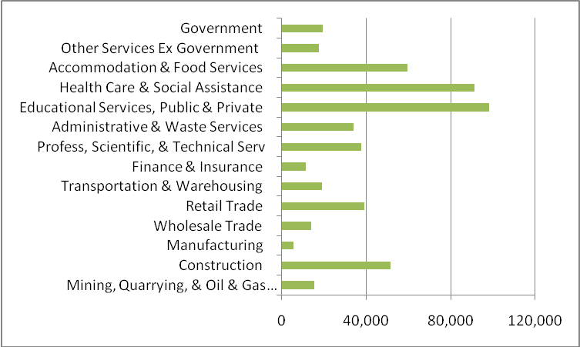

GAINS AND LOSSES

TOP FIVE SECTORS WITH JOB GAINS: 3-DIGIT NAICS LEVEL
NAICS | INDUSTRY | NET CHG | % CHG
611 | Educational Services, Public & Private | 98,080 | 36.4%
722 | Food Services & Drinking Places | 56,050 | 29.7%
621 | Ambulatory Health Care Services | 45,090 | 40.5%
541 | Professional, Scientific, & Tech Services | 37,700 | 20.2%
561 | Administrative & Support Services | 32,530 | 19.0%

TOP FIVE SECTORS WITH JOB LOSSES: 3-DIGIT NAICS LEVEL
NAICS | INDUSTRY | NET CHG | % CHG
491 | Postal Services, Public & Private | -230 | -2.0%
511 | Publishing Industries | -440 | -5.8%
331 | Primary Metal Manufacturing | -480 | -10.5%
323 | Printing & Related Support Activities | -730 | -11.5%
334 | Computer & Electronic Product Mfg | -1,170 | -5.9%

TOP FIVE SECTORS WITH JOB GAINS: 4-DIGIT NAICS LEVEL
NAICS | INDUSTRY | NET CHG | % CHG
6111 | Elementary & Secondary Schools, Public/Private | 77,560 | 42.2%
7221 | Full-Service Restaurants | 30,760 | 35.1%
7222 | Limited-Service Eating Places | 22,250 | 27.1%
6221 | General Medical & Surgical Hopsls, Public/Private | 19,280 | 26.9%
6211 | Offices of Physicians | 17,040 | 41.0%

TOP FIVE SECTORS WITH JOB LOSSES: 4-DIGIT NAICS LEVEL
NAICS | INDUSTRY | NET CHG | % CHG
4411 | Automobile Dealers | -670 | -2.8%
3231 | Printing & Related Support Activities | -730 | -11.5%
3328 | Coating, Engraving, & Heat Treating Metals | -730 | -11.8%
3327 | Machine Shops & Threaded Product Manufacturing | -1,260 | -11.3%
3344 | Semiconductor & Electronic Component Mfg | -1,310 | -29.7%

To view the complete list of 2008-2018 industry or occupational employment projections, go to http://www.wrksolutions.com/employer/lmi/additionalreports.html

Workforce Solutions Source: Texas Workforce Commission, U. S. Department of Labor, BLS

